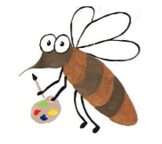

Lyng Primary School Knowledge Organiser

Art

How can I make Stonehenge look realistic using shading?

Year 5

Topic: Art

Autumn

|  |  |
| --- | --- |
| Vocabulary | |
| **Spelling** | **definition** |
| Sketch | A drawing done quickly without a lot of detail |
| Shade | An area of darkness or shadows as shown in a picture |
| Cross hatch | To shade with intersecting parallel lines |
| Texture | The surface quality of a piece of work |
| Tone | How dark or light a colour is |
| Foreground | The area or part of a picture that appears nearest to you |
| Background | Parts of artwork that lie in the distance or behind an object in the foreground |
| Hardness softness | How light or dark the lines or marks of a pencil appear on the paper’s surface |

**Background information for parents and teachers**

Children will study the Stone Age and part of this is learning about Stonehenge which is an archaeological site in Wiltshire. It took many hundreds of years to build with work beginning in the late Neolithic age (3000BC). Over the next thousand years, people made changes to the monument. The children will use this as inspiration for their artwork. They will begin by sketching the shapes and sizes of the stones before adding fine details including shade, tone and textures.

**Children will explore the works of: Da Vinci and John Constable**

**Autumn term**

Stone Age- Stonehenge sketching/shading

|  |
| --- |
| Skills and techniques |
| * Observation – drawing for a sustained period * Experimenting with different pencil grades * Explore tone, pattern, line, shape and visual texture * Altering and refining work |

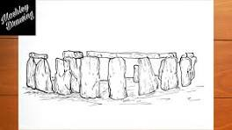

Sketching and drawing

A fundamental artistic technique that involves creating quick, informal simplified drawings. These sketches capture the essence, form and structure of a subject or idea. Artists use sketching as a visual language to explore, communicate and refine their thoughts and concepts.

`

Agreed outcome:

Sketch and shade a replica of Stonehenge